Let’s begin loading the main packages and setting some graphical  
parameters of lattice and latticeExtra.

library(lattice)

library(ggplot2)

# latticeExtra must be loaded after ggplot2 to prevent masking of `layer`

library(latticeExtra)

library(RColorBrewer)

# lattice and latticeExtra configuration

myTheme <- custom.theme.2(

pch=19, cex=0.7, region=rev(brewer.pal(9, 'YlOrRd')),

symbol=brewer.pal(n=8, name="Dark2"))

myTheme$strip.background$col = myTheme$strip.shingle$col =

myTheme$strip.border$col = 'transparent'

myArgs <- list(

as.table=TRUE, between=list(x=0.5, y=0.2),

xscale.components = function(...)

modifyList(xscale.components.default(...), list(top=FALSE)),

yscale.components = function(...)

modifyList(yscale.components.default(...), list(right=FALSE)))

lattice.options(default.theme=myTheme, default.args=modifyList(

lattice.options()$default.args, myArgs))

library(zoo)

And this is the data we will use:

* [aranjuez.RData](https://codingclubuc3m.rbind.io/post/2020-03-03_data/aranjuez.RData)
* [navarra.RData](https://codingclubuc3m.rbind.io/post/2020-03-03_data/navarra.RData)
* [CO2.RData](https://codingclubuc3m.rbind.io/post/2020-03-03_data/CO2.RData)

load('aranjuez.RData')

load('navarra.RData')

load('CO2.RData')

**Time on the horizontal axis**

The most frequent visualization method of a time series uses the  
horizontal axis to depict the time index. This section illustrates  
two variants of this approach to display multivariate time series:  
multiple time series with different scales, and variables with the  
same scale.

**Time graph of variables with different scales**

There is a variety of scientific research interested in the  
relationship among several meteorological variables. A suitable  
approach is to display the time evolution of all of them using a  
panel for each of the variables. The superposition of variables  
with different characteristics is not very useful (unless their  
values were previously rescaled), so this approach is postponed for  
the next section (variables with the same scale).

For the first example we will use the eight years of daily data from  
a meteorological station located at Aranjuez (Madrid).  
This multivariate time series can be displayed with the xyplot  
method of lattice for zoo objects with a panel for each variable.

## The layout argument arranges panels in rows

xyplot(aranjuez, layout = c(1, ncol(aranjuez)))

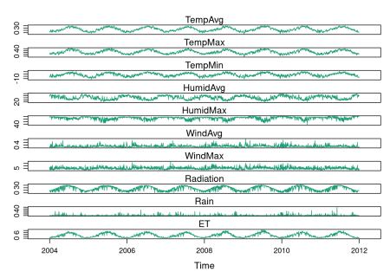

The package ggplot2 provides the generic method autoplot to  
automate the display of certain classes with a simple command. The  
package zoo provides an autoplot method for the zoo class with  
a result similar to that obtained with xyplot.

## facet_free allows each panel to have its own range

autoplot(aranjuez) + facet_free()

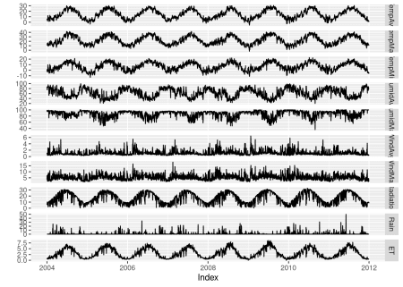

**Time series of variables with the same scale**

As an example of time series of variables with the same scale, we will  
use measurements of solar radiation from different meteorological  
stations.

The first attempt to display this multivariate time series makes use  
of the xyplot.zoo method. The objective of this graphic is to  
display the behavior of the collection as a whole: the series are  
superposed in the same panel (superpose=TRUE) without legend  
(auto.key=FALSE), using thin lines and partial  
transparency. Transparefncy softens overplotting problems and reveals  
density clusters because regions with more overlapping lines are  
darker. Next code displays the variations around the time average  
(avRad).

avRad <- zoo(rowMeans(navarra, na.rm = 1), index(navarra))

pNavarra <- xyplot(navarra - avRad,

superpose = TRUE, auto.key = FALSE,

lwd = 0.5, alpha = 0.3, col = 'midnightblue')

pNavarra

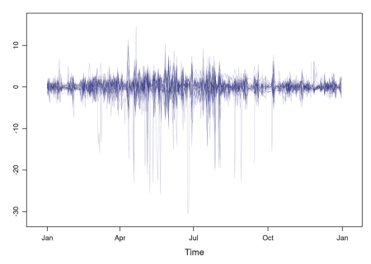

This result can be improved with the horizon graph. The horizon graph  
is useful in examining how a large number of series changes over time,  
and does so in a way that allows both comparisons between the  
individual time series and independent analysis of each  
series. Moreover, extraordinary behaviors and predominant patterns are  
easily distinguished.

This graph displays several stacked series collapsing the y-axis  
to free vertical space:

* Positive and negative values share the same vertical  
  space. Negative values are inverted and placed above the  
  reference line. Sign is encoded using different hues (positive  
  values in blue and negative values in red).
* Differences in magnitude are displayed as differences in color  
  intensity (darker colors for greater differences).
* The color bands share the same baseline and are superposed, with  
  darker bands in front of the lighter ones.

Because the panels share the same design structure, once this  
technique is understood, it is easy to establish comparisons or spot  
extraordinary events. This method is what Tufte described as small  
multiples.

Next code displays the variations of solar radiation around the time  
average with a horizon graph using a row for each time series. In the  
code we choose origin=0 and leave the argument horizonscale  
undefined (default). With this combination each panel has different  
scales and the colors in each panel represent deviations from the  
origin. This is depicted in the color key with the \(\Delta_i\) symbol,  
where the subscript i denotes the existence of multiple panels with  
different scales.

horizonplot(navarra - avRad,

layout = c(1, ncol(navarra)),

origin = 0, ## Deviations in each panel are calculated

## from this value

colorkey = TRUE,

col.regions = brewer.pal(6, "RdBu"))

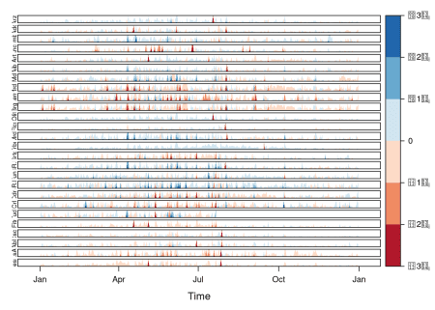

The horizon graph is also useful in revealing the differences between  
a univariate time series and another reference. For example, we might  
be interested in the departure of the observed temperature from the  
long-term average, or in other words, the temperature change over  
time. Let’s illustrate this approach with the time series of daily  
average temperatures measured at the meteorological station of  
Aranjuez. The reference is the long-term daily average calculated with  
ave.

Ta <- aranjuez$TempAvg

timeIndex <- index(aranjuez)

longTa <- ave(Ta, format(timeIndex, '%j'))

diffTa <- (Ta - longTa)

The next code uses horizonplot with the cut-and-stack method to distinguish between years.

years <- unique(format(timeIndex, '%Y'))

horizonplot(diffTa, cut = list(n = 8, overlap = 0),

colorkey = TRUE, layout = c(1, 8),

scales = list(draw = FALSE, y = list(relation = 'same')),

origin = 0, strip.left = FALSE) +

layer(grid.text(years[panel.number()], x = 0, y = 0.1,

gp = gpar(cex = 0.8),

just = "left"))

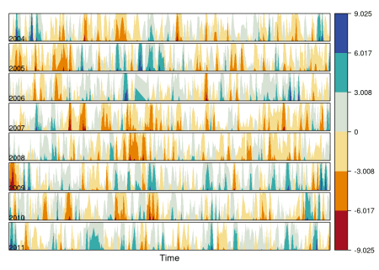

An alternative is a level plot displaying the time series using parts  
of its time index both as independent and as conditioning variable.  
The following code displays the differences with the day of the month on  
the horizontal axis and the year on the vertical axis, with a  
different panel for each month number. Therefore, each cell of the next  
figure corresponds to a certain day of the time series.

year <- function(x)as.numeric(format(x, '%Y'))

day <- function(x)as.numeric(format(x, '%d'))

month <- function(x)as.numeric(format(x, '%m'))

myTheme <- modifyList(custom.theme(region = brewer.pal(9, 'RdBu')),

list(

strip.background = list(col = 'gray'),

panel.background = list(col = 'gray')))

maxZ <- max(abs(diffTa))

levelplot(diffTa ~ day(timeIndex) * year(timeIndex) | factor(month(timeIndex)),

at = pretty(c(-maxZ, maxZ), n = 8),

colorkey = list(height = 0.3),

layout = c(1, 12), strip = FALSE, strip.left = TRUE,

xlab = 'Day', ylab = 'Month',

par.settings = myTheme)

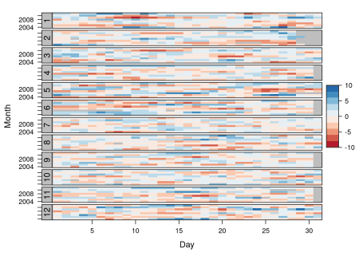

The ggplot version requires a data.frame with the day, year, and month arranged in different columns.

df <- data.frame(Vals = diffTa,

Day = day(timeIndex),

Year = year(timeIndex),

Month = month(timeIndex))

The values (Vals column of this data.frame) are displayed as a level plot thanks to the geom_raster function.

library(scales)

## The packages scales is needed for the pretty_breaks function.

ggplot(data = df,

aes(fill = Vals,

x = Day,

y = Year)) +

facet_wrap(~ Month, ncol = 1, strip.position = 'left') +

scale_y_continuous(breaks = pretty_breaks()) +

scale_fill_distiller(palette = 'RdBu', direction = 1) +

geom_raster() +

theme(panel.grid.major = element_blank(),

panel.grid.minor = element_blank())

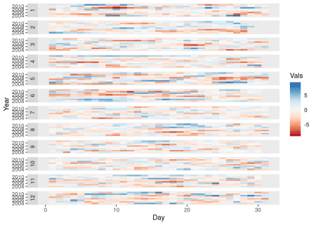

**Interactive graphics**

This section describes the interactive alternatives of the static  
figures included in the previous sections with several packages:  
dygraphs, highcharter, and plotly. These packages  
are R interfaces to JavaScript libraries based on the htmlwidgets  
package.

**Dygraphs**

The dygraphs package is an interface to the dygraphs JavaScript  
library, and provides facilities for charting time-series. It works  
automatically with xts time series objects, or with objects than can  
be coerced to this class. The result is an interactive graph, where  
values are displayed according to the mouse position over the time  
series. Regions can be selected to zoom into a time period.

library(dygraphs)

dyTemp <- dygraph(aranjuez[, c("TempMin", "TempAvg", "TempMax")],

main = "Temperature in Aranjuez",

ylab = "ºC")

widgetframe::frameWidget(dyTemp)

You can customize dygraphs by piping additional commands onto the  
original graphic. The function dyOptions provides several choices  
for the graphic, and the function dyHighlight configures options for  
data series mouse-over highlighting. For example, with the next code  
the semi-transparency value of the non-selected lines is reduced and  
the width of the selected line is increased.

dyTemp %>%

dyHighlight(highlightSeriesBackgroundAlpha = 0.2,

highlightSeriesOpts = list(strokeWidth = 2)) %>%

widgetframe::frameWidget()

An alternative approach to depict the upper and lower variables of  
this time series is with a shaded region. The dySeries function  
accepts a character vector of length 3 that specifies a set of input  
column names to use as the lower, value, and upper for a series with a  
shaded region around it.

dygraph(aranjuez[, c("TempMin", "TempAvg", "TempMax")],

main = "Temperature in Aranjuez",

ylab = "ºC") %>%

dySeries(c("TempMin", "TempAvg", "TempMax"),

label = "Temperature") %>%

widgetframe::frameWidget()

**Highcharter**

The highcharter package is an interface to the highcharts  
JavaScript library, with a wide spectrum of graphics  
solutions. Displaying time series with this package can be achieved  
with the combination of the generic highchart function and several  
calls to the hc_add_series_xts function through the pipe %>%  
operator. Once again, the result is an interactive graph with  
selection and zoom capabilities.

library(highcharter)

library(xts)

aranjuezXTS <- as.xts(aranjuez)

highchart() %>%

hc_add_series(name = 'TempMax',

aranjuezXTS[, "TempMax"]) %>%

hc_add_series(name = 'TempMin',

aranjuezXTS[, "TempMin"]) %>%

hc_add_series(name = 'TempAvg',

aranjuezXTS[, "TempAvg"]) %>%

widgetframe::frameWidget()

**plotly**

The plotly package is an interface to the plotly JavaScript  
library, also with a wide spectrum of graphics solutions. This package  
does not provide any function specifically focused on time  
series. Thus, the time series object has to be transformed into a  
data.frame including a column for the time index. If the  
data.frame is in *wide* format (one column per variable), each  
variable will be represented with a call to the add_lines  
function. However, if the data.frame is in *long* format (a column  
for values, and a column for variable names) only one call to  
add_lines is required. The next code follows this approach using the  
combination of fortify, to convert the zoo object into a  
data.frame, and melt, to transform from wide to long format.

aranjuezDF <- fortify(aranjuez[,

c("TempMax",

"TempAvg",

"TempMin")],

melt = TRUE)

summary(aranjuezDF)

## Index Series Value

## Min. :2004-01-01 TempMax:2898 Min. :-12.980

## 1st Qu.:2005-12-29 TempAvg:2898 1st Qu.: 7.107

## Median :2008-01-09 TempMin:2898 Median : 13.560

## Mean :2008-01-03 Mean : 14.617

## 3rd Qu.:2010-01-03 3rd Qu.: 21.670

## Max. :2011-12-31 Max. : 41.910

## NA's :10

Next code produces an interactive graphic with the generic function  
plot_ly connected with add_lines through the pipe operator,  
%>%.

library(plotly)

plot_ly(aranjuezDF) %>%

add_lines(x = ~ Index,

y = ~ Value,

color = ~ Series) %>%

widgetframe::frameWidget()

**Time as a conditioning or grouping variable**

Previously we learned to display the time evolution of multiple time  
series with different scales. But, what if instead of displaying the  
time evolution we want to represent the relation between the  
variables? This section follows this approach: first, a scatterplot  
matrix using groups is defined according to the time as a grouping  
variable; next, an enhanced scatterplot with time as a conditioning  
variable is produced using the small multiples technique.

**Scatterplot matrix: time as a grouping variable**

The scatterplot matrices are based on the technique of small  
multiples: small, thumbnail-sized representations of multiple images  
displayed all at once, which allows the reader to immediately, and in  
parallel, compare the inter-frame differences. A scatterplot matrix  
is a display of all pairwise bivariate scatterplots arranged in a \(p \times p\) matrix for \(p\) variables. Each subplot shows the relation  
between the pair of variables at the intersection of the row and  
column indicated by the variable names in the diagonal panels.

This graphical tool is implemented in the splom function. The  
following code displays the relation between the set of  
meteorological variables using a sequential palette from the  
ColorBrewer catalog (RbBu, with black added to complete a  
twelve-color palette) to encode the month. The order of colors of  
this palette is chosen in order to display summer months with  
intense colors and to distinguish between the first and second  
half of the year with red and blue, respectively.

aranjuezDF <- as.data.frame(aranjuez)

aranjuezDF$Month <- format(index(aranjuez), '%m')

## Red-Blue palette with black added (12 colors)

colors <- c(brewer.pal(n = 11, 'RdBu'), '#000000')

## Rearrange according to months (darkest for summer)

colors <- colors[c(6:1, 12:7)]

splom(~ aranjuezDF[1:10], ## Do not include "Month"

groups = aranjuezDF$Month,

auto.key = list(space = 'right',

title = 'Month', cex.title = 1),

pscale = 0, varname.cex = 0.7, xlab = '',

par.settings = custom.theme(symbol = colors,

pch = 19),

cex = 0.3, alpha = 0.1)

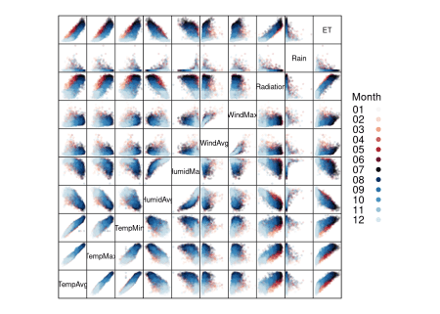

The ggplot2 version of this graphic is produced thanks to the  
ggpairs function provided by the GGally package.

library(GGally)

ggpairs(aranjuezDF,

columns = 1:10, ## Do not include "Month"

upper = list(continuous = "points"),

mapping = aes(colour = Month, alpha = 0.1))

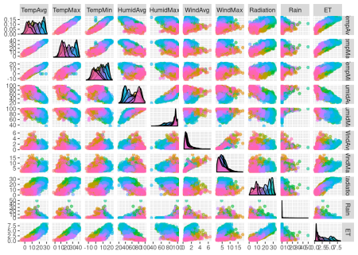

**Scatterplot with time as a conditioning variable**

Previous graphics use colors to encode months. Instead, we will now  
display separate scatterplots with a panel for each month. In  
addition, the statistic type (average, maximum, minimum) is included  
as an additional conditioning variable.

First, the dataset must be reshaped from the wide format  
(one column for each variable) to the long format (only one column for  
the temperature values with one row for each observation). This task  
is easily accomplished with the melt function included in the  
reshape2 package.

library(reshape2)

aranjuezRshp <- melt(aranjuezDF,

measure.vars = c('TempMax',

'TempAvg',

'TempMin'),

[variable.name](http://variable.name) = 'Statistic',

[value.name](http://value.name) = 'Temperature')

This matrix of panels can be displayed with ggplot using  
facet_grid. Next code uses partial transparency to cope with  
overplotting, small horizontal and vertical segments (geom_rug) to  
display points density on both variables, and a smooth line in each  
panel.

ggplot(data = aranjuezRshp, aes(Radiation, Temperature)) +

facet_grid(Statistic ~ Month) +

geom_point(col = 'skyblue4', pch = 19, cex = 0.5, alpha = 0.3) +

geom_rug() +

stat_smooth(se = FALSE, method = 'loess',

col = 'indianred1', lwd = 1.2) +

theme_bw()

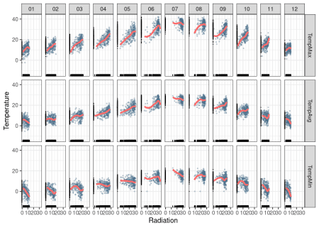

The version with lattice needs the useOuterStrips function from  
the latticeExtra package, which prints the names of the conditioning  
variables on the top and left outer margins.

useOuterStrips(

xyplot(Temperature ~ Radiation | Month * Statistic,

data = aranjuezRshp,

between = list(x = 0),

col = 'skyblue4', pch = 19,

cex = 0.5, alpha = 0.3)) +

layer({

panel.rug(..., col.line = 'indianred1',

end = 0.05, alpha = 0.6)

panel.loess(..., col = 'indianred1',

lwd = 1.5, alpha = 1)

})

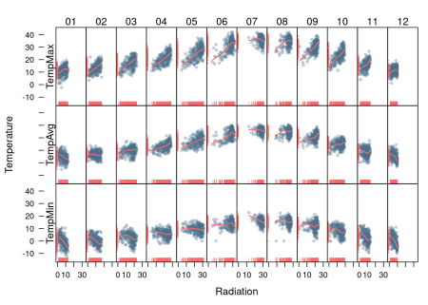

**Time as a complementary variable**

In this section, time will be used as a complementary variable which  
adds information to a graph where several variables are  
confronted. We will illustrate this approach with the evolution of  
the relationship between Gross National Income (GNI) and carbon  
dioxide (\(CO_2\)) emissions for a set of countries extracted from the  
database of the World Bank Open Data. We will try several solutions  
to display the relationship between \(CO_2\) emissions and GNI over  
the years using time as a complementary variable.

**Polylines**

Our first approach is to display the entire data in a panel with a  
scatterplot using country names as the grouping factor. Points of each  
country are connected with polylines to reveal the time evolution.

## lattice version

xyplot(GNI.capita ~ CO2.capita, data = CO2data,

xlab = "Carbon dioxide emissions (metric tons per capita)",

ylab = "GNI per capita, PPP (current international $)",

groups = Country.Name, type = 'b')

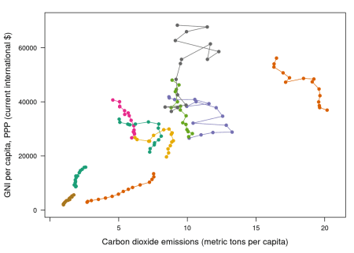

Three improvements can be added to this graphical result:

1. Define a better palette to enhance visual discrimination between  
   countries.
2. Display time information with labels to show year values.
3. Label each polyline with the country name instead of a legend.

**Choosing colors**

The Country.Name categorical variable will be encoded with a  
qualitative palette, namely the first five colors of Set1 palette  
from the RColorBrewer package. Because there are more countries  
than colors, we have to repeat some colors to complete the number of  
levels of the variable Country.Name. The result is a palette with  
non-unique colors, and thus some countries will share the same  
color. This is not a problem because the curves will be labeled, and  
countries with the same color will be displayed at enough distance.

nCountries <- nlevels(CO2data$Country.Name)

pal <- brewer.pal(n = 5, 'Set1')

pal <- rep(pal, length = nCountries)

Adjacent colors of this palette are chosen to be easily  
distinguishable. Therefore, the connection between colors and  
countries must be in such a way that nearby lines are encoded with  
adjacent colors of the palette. A simple approach is to calculate the  
annual average of the variable to be represented along the x-axis  
(CO2.capita), and extract colors from the palette according to the  
order of this value.

## Rank of average values of CO2 per capita

CO2mean <- aggregate(CO2.capita ~ Country.Name,

data = CO2data, FUN = mean)

palOrdered <- pal[rank(CO2mean$CO2.capita)]

## simpleTheme encapsulates the palette in a new theme for xyplot

myTheme <- simpleTheme(pch = 19, cex = 0.6, col = palOrdered)

## lattice version

pCO2.capita <- xyplot(GNI.capita ~ CO2.capita,

data = CO2data,

xlab = "Carbon dioxide emissions (metric tons per capita)",

ylab = "GNI per capita, PPP (current international $)",

groups = Country.Name,

par.settings = myTheme,

type = 'b')

pCO2.capita

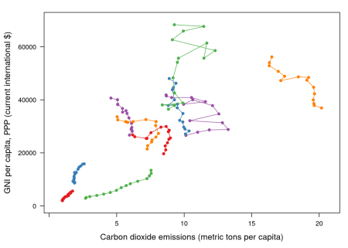

## ggplot2 version

gCO2.capita <- ggplot(data = CO2data,

aes(x = CO2.capita,

y = GNI.capita,

color = Country.Name)) +

geom_point() + geom_path() +

scale_color_manual(values = palOrdered, guide = FALSE) +

xlab('CO2 emissions (metric tons per capita)') +

ylab('GNI per capita, PPP (current international $)') +

theme_bw()

**Labels to show time information**

This result can be improved with labels displaying the years to show  
the time evolution. The panel function panel.text prints the  
year labels with the combination of +.trellis, glayer_ and  
panel.text. Using glayer_ instead of glayer we ensure that the  
labels are printed below the lines.

## lattice version

pCO2.capita <- pCO2.capita +

glayer_(panel.text(...,

labels = CO2data$Year[subscripts],

pos = 2, cex = 0.5, col = 'gray'))

pCO2.capita

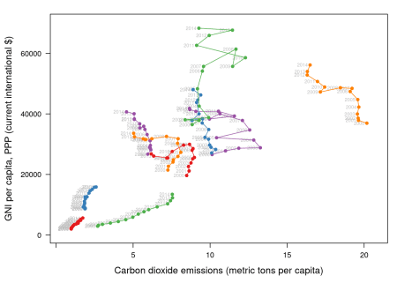

## ggplot2 version

gCO2.capita <- gCO2.capita + geom_text(aes(label = Year),

colour = 'gray',

size = 2.5,

hjust = 0, vjust = 0)

**Country names: positioning labels**

The common solution to link each curve with the group value is to add  
a legend. However, a legend can be confusing with too many items. In  
addition, the reader must carry out a complex task: Choose the line,  
memorize its color, search for it in the legend, and read the country  
name.

A better approach is to label each line using nearby text with the  
same color encoding. A suitable method is to place the labels  
avoiding the overlapping between labels and lines. The package  
directlabels includes a wide repertory of positioning methods to  
cope with overlapping. The main function, direct.label, is able to  
determine a suitable method for each plot, although the user can  
choose a different method from the collection or even define a custom  
method. For the pCO2.capita object, the best results are obtained  
with extreme.grid.

library(directlabels)

## lattice version

direct.label(pCO2.capita,

method = 'extreme.grid')

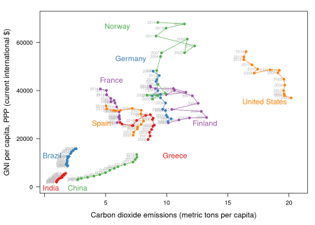

## ggplot2 version

direct.label(gCO2.capita, method = 'extreme.grid')

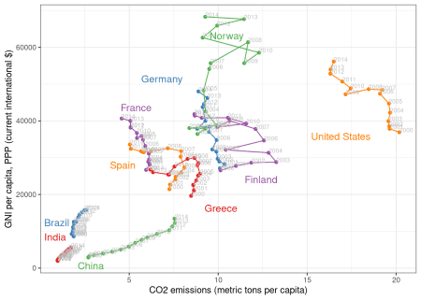

**Interactive graphics: animation**

This section describes how to display the data through animation with  
interactive functionalities with a solution that resembles the motion  
chart product published by Gapminder.

Gapminder is an independent foundation based in Stockholm,  
Sweden. Its mission is “to debunk devastating myths about the world  
by offering free access to a fact-based world view.” They provide free  
online tools, data, and videos “to better understand the changing  
world.” The initial development of Gapminder was the Trendalyzer  
software, used by Hans Rosling in several sequences of his documentary  
“The Joy of Stats.”

The information visualization technique used by Trendalyzer is an  
interactive bubble chart. By default it shows five variables: two  
numeric variables on the vertical and horizontal axes, bubble size and  
color, and a time variable that may be manipulated with a slider. The  
software uses brushing and linking techniques for displaying the  
numeric value of a highlighted country.

We will mimic the Trendalyzer/Motion Chart solution with the package  
plotly, using traveling bubbles of different colors and with radius  
proportional to the values of the variable CO2.PPP. Previously, you  
should watch the magistral video “[200 Countries, 200 Years, 4 Minutes](https://www.gapminder.org/videos/200-years-that-changed-the-world-bbc/)”.

The plotly package has already been used previously to create an  
interactive graphic representing time in the x-axis. In this section  
this package produces an animation piping the result of the plot_ly  
and add_markers functions through the animation_slider function.

Variables CO2.capita and GNI.capita are represented in the x-axis  
and y-axis, respectively.

p <- plot_ly(CO2data,

x = ~CO2.capita,

y = ~GNI.capita,

sizes = c(10, 100),

marker = list(opacity = 0.7,

sizemode = 'diameter'))

CO2.PPP is encoded with the circle sizes, while Country.Name is  
represented both with colours and with labels.

p <- add_markers(p,

size = ~CO2.PPP,

color = ~Country.Name,

text = ~Country.Name, hoverinfo = "text",

ids = ~Country.Name,

frame = ~Year,

showlegend = FALSE)

Finally, the animation is created with animation_opts, to customize the  
frame and transition times, and with animation_slider to define the  
slider.

p <- animation_opts(p,

frame = 1000,

transition = 800,

redraw = FALSE)

p <- animation_slider(p,

currentvalue = list(prefix = "Year "))

widgetframe::frameWidget(p)